ASSIGNMNENT 5

NAME: Thirumalasri.P

REG. NO. :240701569
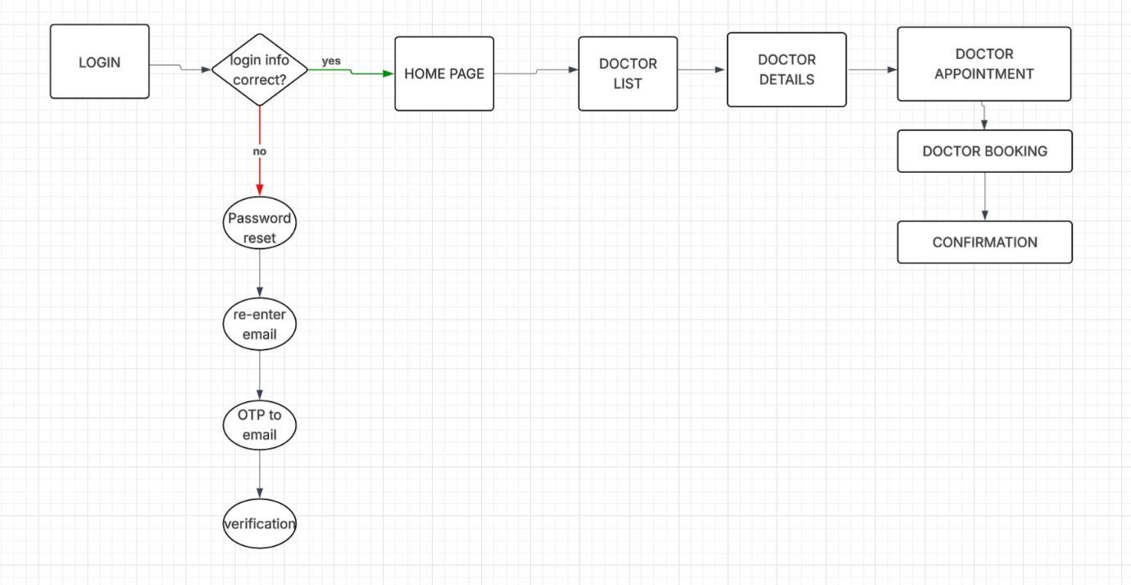
You can paste the following clear explanation in your assignment for the flowchart you created.

Doctor Appointment Mobile Application Flowchart Explanation
A flowchart is a diagram that represents the sequence of steps involved in a process or system. It uses different symbols such as rectangles, diamonds, and arrows to show actions, decisions, and the flow of the process. Flowcharts help in understanding and designing a system easily.
The given flowchart represents the working process of a Doctor Appointment Mobile Application. It explains how a user logs in, searches for doctors, books an appointment, and receives confirmation.

1. Login
The process starts with the Login page, where the user enters their login credentials such as email and password to access the application.

2. Login Verification
After entering the login details, the system checks whether the login information is correct or not.
- Yes: If the login details are correct, the user is directed to the Home Page.
- No: If the login details are incorrect, the user must reset the password.

3. Password Reset Process
If the login fails, the system guides the user through the password recovery process.
- The user selects Password Reset.
- The user re-enters their email address.
- The system sends an OTP (One Time Password) to the email.
- After entering the OTP, the system performs verification to confirm the user’s identity.
Once verification is successful, the user can log in again.

4. Home Page
After successful login, the user enters the Home Page of the application.
This page allows the user to search for doctors and access other features of the healthcare application.

5. Doctor List
From the home page, the user can view the Doctor List, which displays available doctors along with their specialties.

6. Doctor Details
When a doctor is selected, the Doctor Details page shows information such as:
- Doctor’s name
- Specialization
- Experience
- Available appointment slots

7. Doctor Appointment
After viewing the details, the user proceeds to the Doctor Appointment page to choose a suitable date and time.

8. Doctor Booking
Once the appointment time is selected, the system performs Doctor Booking, which schedules the appointment with the selected doctor.

9. Confirmation
Finally, the system displays a Confirmation message, informing the user that the appointment has been successfully booked.

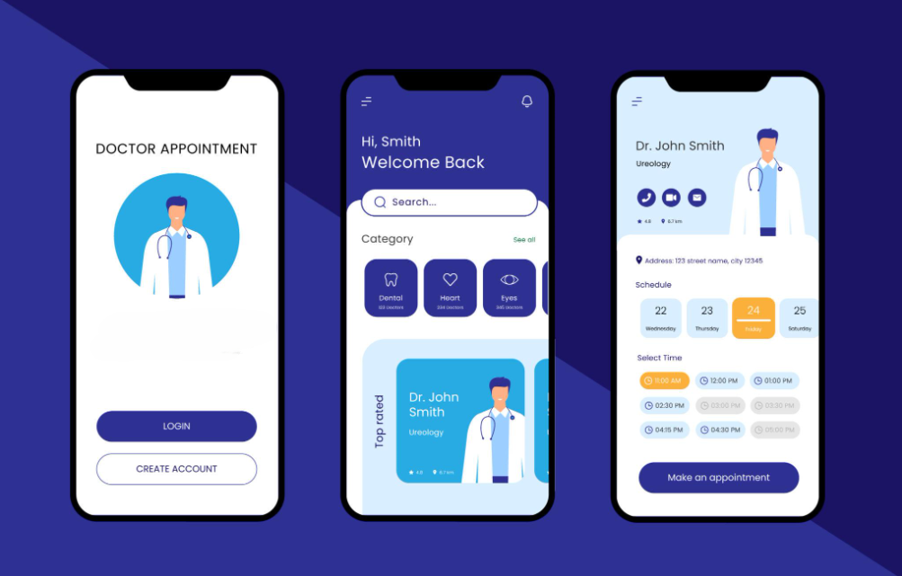

Doctor Appointment Mobile Application – Screen Explanation
The image shows the user interface (UI) design of a Doctor Appointment Mobile Application. This design demonstrates how users interact with the application to search for doctors and book appointments easily using their smartphones. Doctor appointment applications help patients schedule and manage their medical visits without visiting the hospital physically. the design contains three main screens of the application.

1. Login Screen
The first screen is the Login page of the application.
It contains the title “Doctor Appointment”, an illustration of a doctor, and two buttons:
- Login – Allows existing users to enter the application using their account credentials.
- Create Account – Allows new users to register and create an account.
This screen acts as the entry point of the application, where users authenticate themselves before accessing other features.

2. Home Screen
The second screen represents the Home Page (Dashboard) of the mobile application.
Key features of this screen include:
- Welcome message – Greets the user when they open the app.
- Search bar – Allows users to search for doctors quickly.
- Category section – Shows different medical specialties such as:
  - Dental
  - Heart
  - Eyes
- Top Rated Doctor section – Displays recommended doctors with their profiles.
This screen helps users easily find doctors based on specialization and availability.

3. Doctor Details and Appointment Screen
The third screen shows the Doctor Profile and Appointment Booking page.
It includes the following information:
- Doctor’s name and specialization
- Doctor profile image
- Hospital address
- Schedule (available dates)
- Available time slots
Users can choose their preferred date and time and then click the “Make an appointment” button to book a consultation.

https://lucid.app/lucidchart/f89c0bac-a00d-4aa7-89ab-59aad80dad13/edit?viewport_loc=-308%2C146%2C2266%2C1227%2C0_0&invitationId=inv_2c7163a4-ad37-451b-891b-4371d2106d40

